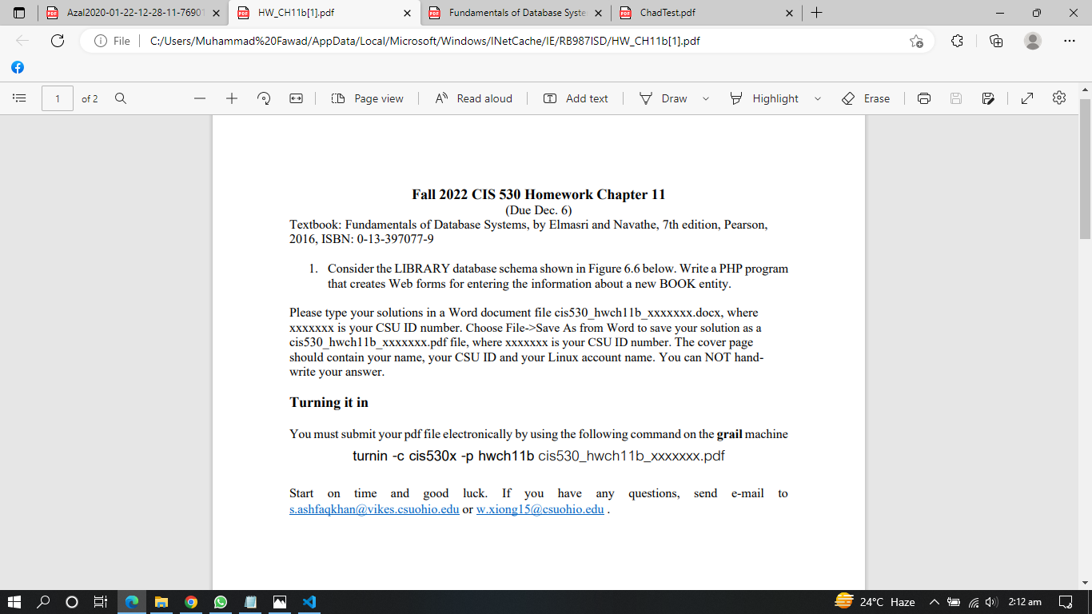

**SOL:**

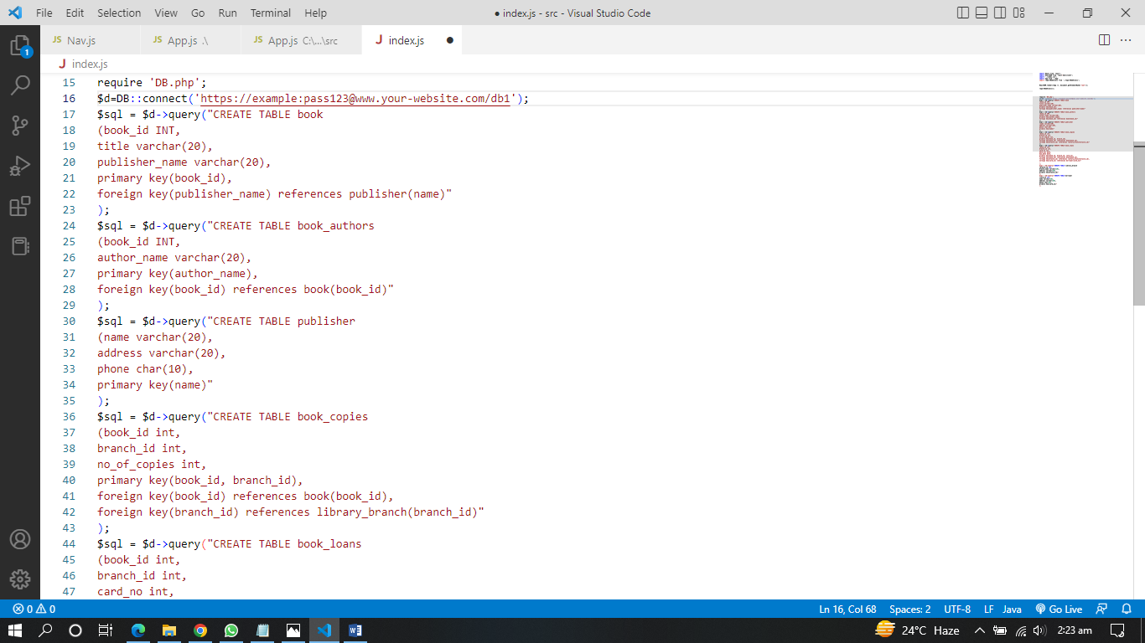

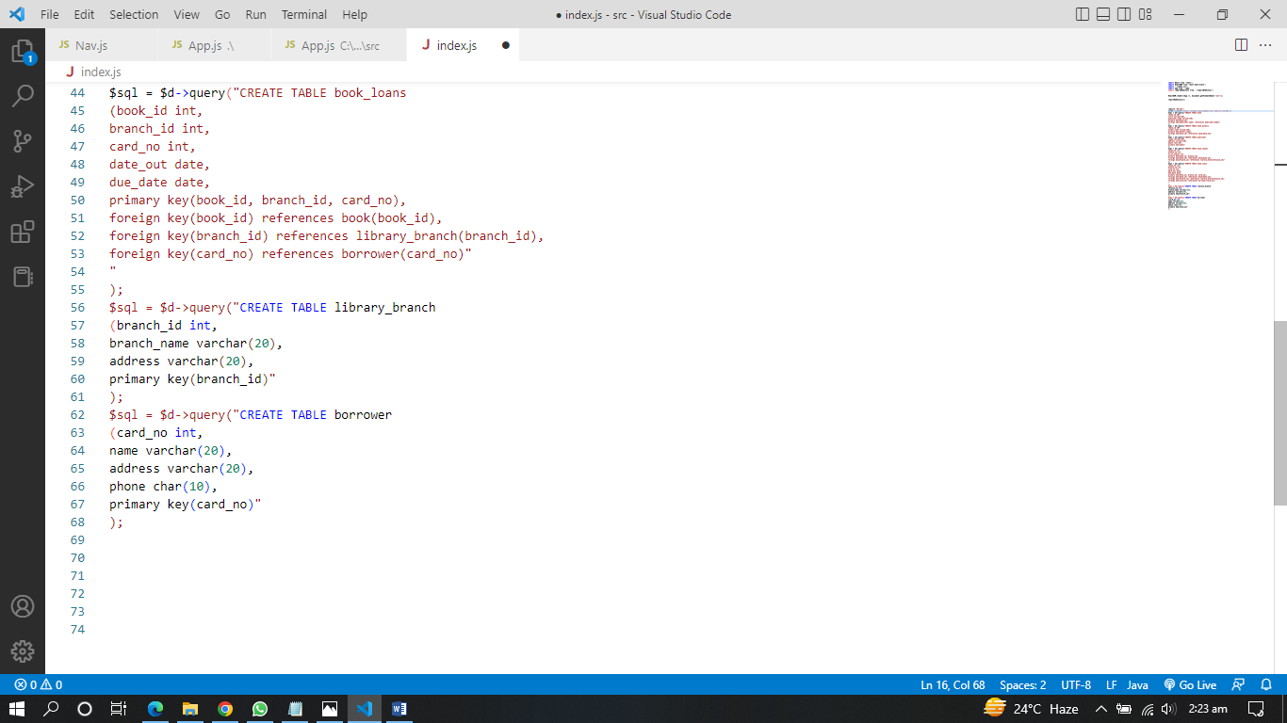

**Explanation:**

**Be sure to use your own website URL for connection.**

A connection with the database is created in the second line of code; tables are created in the third line, and if there is an error, a statement is used to check if it can occur.

**Result:**

So query("CREATE TABLE TableName (ColumnName VARCHAR(20) ) ; ) is for creating tables. For connection database use: DB::connect('database_url');